Program Information | [Lesson Title]  Estimation with Percents |  |  |  |  | TEACHER NAME  Paula Mullet |  |  | PROGRAM NAME  Cuyahoga Community College
Program Information | [Unit Title]  Estimation  Ratios & Proportions |  |  |  |  | NRS EFL  4 |  |  | TIME FRAME  180 minutes
Instruction | ABE/ASE Standards – Mathematics
Instruction | Numbers (N) |  |  | Algebra (A) |  | Geometry (G) |  |  | Data (D)
Instruction | Numbers and Operation |  |  | Operations and Algebraic Thinking |  | Geometric Shapes and Figures |  |  | Measurement and Data
Instruction | The Number System |  |  | Expressions and Equations |  | Congruence |  |  | Statistics and Probability
Instruction | Ratios and Proportional Relationships |  | N.4.9  N.4.12 | Functions |  | Similarity, Right Triangles. And Trigonometry |  |  | Benchmarks identified in RED are priority benchmarks. To view a complete list of priority benchmarks and related Ohio Aspire lesson plans, please see the Curriculum Alignments located on the Teacher Resource Center.
Instruction | Number and Quantity |  |  |  |  | Geometric Measurement and Dimensions
Instruction |  |  |  |  |  | Modeling with Geometry
Instruction | Mathematical Practices (MP)
Instruction |  | Make sense of problems and persevere in solving them. (MP.1) |  |  |  |  | Use appropriate tools strategically. (MP.5)
Instruction |  | Reason abstractly and quantitatively. (MP.2) |  |  |  |  | Attend to precision. (MP.6)
Instruction |  | Construct viable arguments and critique the reasoning of others. (MP.3) |  |  |  |  | Look for and make use of structure. (MP.7)
Instruction |  | Model with mathematics. (MP.4) |  |  |  |  | Look for and express regularity in repeated reasoning. (MP.8)
 | LEARNER OUTCOME(S)  - Students will incorporate estimations when solving percent problems involving shopping and eating out activities. |  |  |  |  | ASSESSMENT TOOLS/METHODS  - Students will use ads from local newspapers flyers and menus to create percentage problems. These authentic activities will be compiled by the teacher and used to evaluate student’s ability to find the cost of sale items and tips.
LEARNER PRIOR KNOWLEDGE

- Students should have a basic understanding of whole number operations (add, subtract, multiply and divide) and rounding numbers.
This lesson is part two of a pair of lessons on estimation, the first lesson is Let's Go Shopping: Estimation at the Mall.

 | INSTRUCTIONAL ACTIVITIES  - Discuss with the class when they come across/use percentages in their daily life. Record the responses on an overhead, flip chart or chalk board. The students might mention: test scores in school, borrowing money, interest on savings accounts, newspaper articles (prices going up a certain percent), baby growth charts, tipping at a restaurant, and sale prices in stores. Make sure that the list includes the idea that percents are often used by the retail industry to describe the discount when an item is on sale.  Next, ask the students, “What does percent mean? If I save 25% on a $20 item what does it mean? What does the 80% on the top of a test paper mean?” Discuss the students’ ideas on the meaning of percent. Write down all ideas given. Once the list is compiled discuss the items on the list. Be sure to answer questions and correct any misconceptions that have come up in the discussion.  Before moving on, be sure that students understand the concept of percent. See Percent Information Teacher Resource. Use the percent grids or percent circles to help students understand percentages, if needed.  - Ask the class what they do when they are shopping and want to buy an item that is on sale? How do they know the sale price? Discuss their strategies. Explain to the students that today they will learn some strategies that will help them when they need to find the price of an item on sale.  Pass out the Benchmark Percents handout included with the lesson. This sheet gives strategies that can be used to mentally calculate percents. Review each of the strategies on the sheet. Be sure to spend time practicing each technique. Depending on the level of your students, you can make the numbers you use easier or more difficult. I like to use numbers that sound like actual prices ($34.99, $14.98, $19.99, etc.). Students can round the prices off or select a close compatible number to use when they calculate the percent of the number.  - Distribute copies of a store ad with various items being discounted a specific percent. (Although most ads list the percent off and the sale price, this doesn’t matter.) After reviewing their strategies for finding prices, use the sale ads to make up a problem. If the ad flyer has men’s shirts for 25% off (the discount), ask the students how much they would save if they bought a shirt for $19.99. After the students are comfortable rounding off the price of the item and calculating the discount, ask them the sale price of the item. Help the students recognize that the sale price of an item is found by subtracting the percent discount from the original price. Post the following equation on the chalk board or on a sentence strip in the room: “Original price (100%) - % of discount = % of the sale price.” The students need lots of practice with this concept. Continue to write this basic equation on the board. For example, if an item is 30% off, the equation would be 100% (original price) - 30% (discount) = 70% (sale price).  Continue to use the basic sale flyer to calculate both the discount and sale price for a variety of items. The students have fun making up their own items to purchase and swapping their problems with their classmates.  Introduce students to a second strategy for finding the sale price of an item. First subtract the percent discount from 100%, thereby finding the percent of the sale price. Next, using the percent of the sale price, calculate this percent of the total. Let students know that this is another possible way to calculate the price of an item on sale.  Continue to estimate sale prices and discounts by rounding off the original prices and calculating the percent by using the strategies on the Benchmark Percent Sheet.  - Another situation requiring the use of percents is tipping the wait staff in a restaurant. My GED students have told me a 15% tip is fine if you can go to the restaurant without making a reservation. If a reservation is required, you should tip 20%. Help your students calculate a 15% tip by following these steps:  - Round the price of the meal to the nearest dollar.  - Divide the cost by 10. (Tip: Teach students to move the decimal point one place to the left to quickly divide by 10).  - Help your class recognize that since 5 is half of 10, then 5% is half of 10%. Divide the value for 10% in half.  - Finally add the values for 10% and 5% together to find 15%: the amount to tip.  Pass out a variety of menus and let students select a meal to order. Another student in the class can calculate the cost of the meal (including tip) for the meal.  - Distribute ads with “buy one – get one half off” offers and coupons. These ads provide additional problem solving opportunities. Again, the prices of the items the students are “purchasing” can be adjusted in difficulty depending on student skill. Encourage the students to do as many of the calculations as possible mentally, but to write down numbers they might need to remember. Go over several examples with the students. Be sure to write down and label the various steps in the problem as you go along so the students can see the steps required to find the answer. Discuss with the students if these offers are a good deal. Why or why not? What is the actual percent being saved?  - Distribute ads with coupons for an additional 10, 15 or 20% off your total purchase. Estimate the additional savings these coupons generate. If an item is on sale for 25% off, and a coupon for an additional 15% off is used, is the total savings 40% off?  Teacher Note The situations discussed in steps 5 and 6 generate important ideas that lead to deeper understanding about percents. |  |  |  |  | RESOURCES  Percent Information Teacher Resource attached  Student copies of Benchmark Percents (attached)  Copies of sale ads from the newspaper. These can be circulars or one page ads. If possible include ads with the following situations: Coupons with an “extra percent off the sale price” and “buy one –get one at 50% off.”  Menus from local restaurants  Extension activities:  Hunsader, S. (n.d.). Conversions: Fractions-Decimals- Percents. Retrieved from https://www.wisc-online.com/learn/formal-science/mathematics/abm1301/conversions-fractions-decimals--percents  Hunsader, S. (n.d.). Conversions: Fractions-Decimals- Percents Pre-Test. Retrieved from https://www.wisc-online.com/learn/formal-science/mathematics/abm1201/conversions-fractions-decimals--percents-pre-  McKinney, M. (n.d.). Solving Percent Problems Using a Pyramid Grid. Retrieved from http://www.wisc-online.com/objects/index_tj.asp?objID=ABM4502
DIFFERENTIATION

- Provide calculators for students
- Provide Benchmark Percent Sheet to use as a reference sheet during the lesson
- Have students work with a partner
- Use the percent circle handouts, percent grids, and paper plate manipulative to aid in understanding of percents. The manipulative can be made using 2 lunch size, different colored paper plates (can be found at local dollar store). Cut a radii to the center of each plate. Slide them together on the two cuts. They can be slid around so students can quickly illustrate basic percents (25%, 50%, etc.) of one of the colors

Reflection | TEACHER REFLECTION/LESSON EVALUATION
Reflection | ADDITIONAL INFORMATION  Estimation with Percents Learning Objects will give students additional practice converting fractions, decimals and percents. Students need lots of practice estimating percentages.

Percent Information Teacher Resource
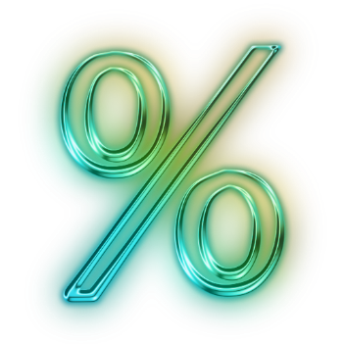
Percent is one way to represent a part of a whole.

Fractions, decimal fractions and percents can all be used to represent quantities that are less than one. Also, mixed fractions, decimals and percents can also be used to represent more than the whole.

Percent is another name for hundredths. If a fraction or decimal can be expressed as hundredths, the term percent can be substituted for the word hundredths.

¾ is equivalent to 75/100 is equivalent to 0.75 is equivalent to 75%

It is important to understand that hundredths in decimals is the same as percent. The decimal 0.50 is equivalent to 50%. This is more meaningful than memorizing a rule: “Move the decimal point 2 places to the right to change a decimal fraction to a percent.”

The basic elements of a percent problem are the percent/fraction (rate), the part (amount) and the base (whole). Most percent problems will provide two of these numbers and the student will be asked to find the third. There are 3 basic types of percent problems, in which the student will solve for one of the three numbers.

It is important for students to spend time working with nice numbers and explore percents in real contexts before using specific rules or procedures. Even when calculating an answer, often an estimate is all that is needed. Percents can be “rounded” to nice numbers (ie.73.5% to 75%) which are compatible with the numbers in the problem. By using this strategy, many problems can be solved using mental math and simple fractions.

Ideas to Help Students Understand Percents

Use hundreds grids and shade in various percentages of the grid. Shade a grid and swap grids with another student. Estimate the percent which is shaded. What percent is not shaded?

NCTM has printable percentage grids and ideas to use them at:
http://illuminations.nctm.org/LessonDetail.aspx?id=L249

The link below includes a PDF for 12 percent grids on one sheet
http://www.mhhe.com/math/ltbmath/bennett_nelson/conceptual/student/grids/PercentGrids.pdf

McGraw-Hill has a printable percent circle at the link below
http://highered.mcgraw-hill.com/sites/dl/free/0070973385/505858/mhr_ml8_ProjectIdeas_Master12.pdf

Percent Information Teacher Resource
Benchmark Percents
100% = 1 = 1/1 = whole amount
If you have 100% of the number, you have the entire number.

50% = 1/2
If you have 50% of a number, you have half of the number.
Find 50% by dividing the number by 2 (in half)

25% = 1/4
If you have 25% of a number, you have ¼ (a quarter) of the number.
Find 25% by dividing the number by 4 or dividing the number by 2 (in half) twice.

10% = 1/10
If you have 10% of a number, you have 1/10 of the number.
Find 10% by dividing the number by 10. You can do this by moving the decimal point in your number one place to the left.

5% = 1/20
To find 5%, first find 10%, then divide that value in half.

1% = 1/100
If you have 1% of a number, you have 1/100 of the number.
Find 1% by dividing the number by 100. You can do this by moving the decimal point in your number 2 places to the left.

20% = 1/5
If you have 20% of a number, you have 1/5 of the number.
Find 20% by dividing the number by 5 or finding 10% and then doubling it.

33 1/3% = 1/3
If you have 33-1/3% of a number, you have 1/3 of the number.
Find 33-1/3% by dividing the number by 3.

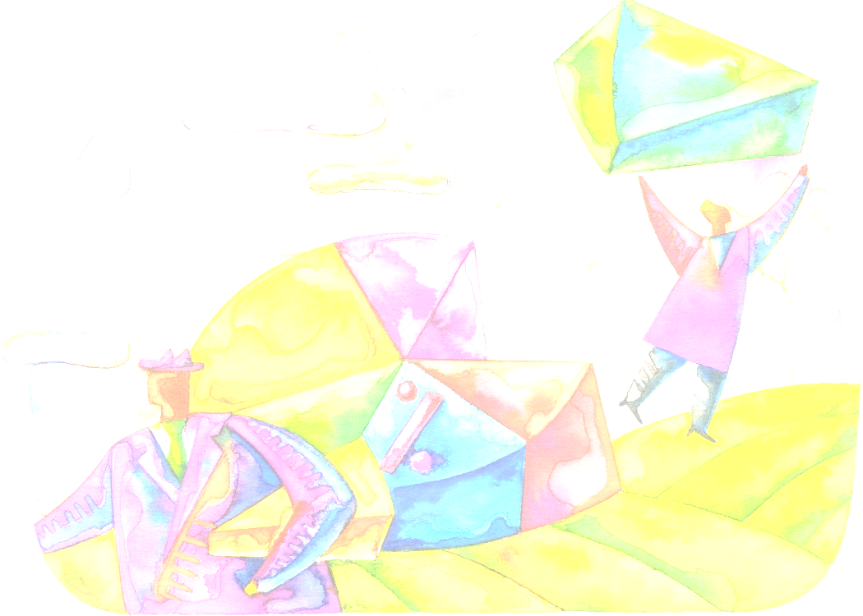
66 2/3% = 2/3
If you have 66-2/3% of a number, you have 2/3 of the number.
Find 66-2/3% by dividing the number by 3 and then multiplying this answer by 2 (doubling it).

200% = 2 = 2/1 = 2 wholes
If you have 200% of a number, you have twice the number
Find 200% by multiplying the number by 2

Remember The percent you have + the percent you do not have = 100%
(25% + 75% = 100% so 75% = 100% - 25%)
If something is on sale for a percentage off (discount), you will pay the percentage that is left when you subtract the discount.
(Original price – the percent off = the sale price)

To find a 15% tip, first find 10%, than find 5% (half of 10%), finally add the two values together.
5% + 10% = 15%
Benchmark Percents Handout


http://www.wisconline.org

Conversions: Fractions-Decimals- Percents
Author: Susi Hunsader
School: Fox Valley Technical College
Description: Students recognize the conversions used among fractions, decimals, and percents
http://www.wisc-online.com/objects/index_tj.asp?objID=ABM1301

Conversions: Fractions-Decimals- Percents Pre-Test
Author: Susi Hunsader
School: Fox Valley Technical College
Description: Students perform conversions among fractions, decimals, and percentages in this assessment.
http://www.wisc-online.com/objects/index_tj.asp?objID=ABM1201

Solving Percent Problems Using a Pyramid Grid
Author: MarQulyn McKinney
School: Milwaukee Area Technical College
Description: Students use the pyramid method to solve percent problems. The pyramid grid provides a visual way to set up the equation.
http://www.wisc-online.com/objects/index_tj.asp?objID=ABM4502

Estimation with Percents Learning Objects

